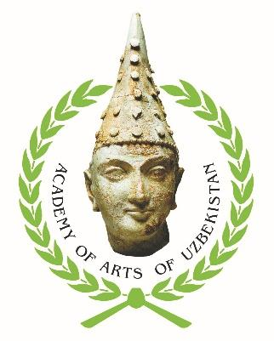

ACADEMY OF ARTS OF UZBEKISTAN

OPEN CALL

The Academy of Arts of Uzbekistan invites you to participate
at the X Tashkent International Biennale
of Contemporary Art,
which will be held from 14 to 18 October 2024 in the city of Tashkent (Uzbekistan). Can take part in the Biennale artists of various areas of contemporary art and present your work on the topic
“Art and World”.

In addition to the main exhibition, the biennale will host a number of artistic and cultural events, such as exhibitions, lectures and master classes, an international conference, and a tour of the cities of Uzbekistan.

All expenses of foreign participants for their stay (meals, internal transportation, accommodation) in Tashkent, except for flights,
will be covered by the Organizing Committee.

Applications for participation in the Biennale are accepted until August 15, 2024 via Google form:
https://forms.gle/aUEMyfrsyQUsrp7b7

(detailed information is given in the attachment to this letter)

*Organizers have the right to make changes to the event program

